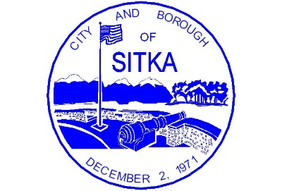
City and Borough of Sitka
100 Lincoln Street • Sitka, Alaska 99835
Coast Guard City, USA

March 18, 2020

Public Service Announcement:

Playgrounds / Batting Cage Closed

To prevent or slow the spread of the Coronavirus Disease (COVID-19), the City and Borough of Sitka is closing all school playgrounds, the Sitka Community Playground, and Moller Complex batting cage and playgrounds.

We encourage children to stay active, get fresh air, yet still practice social distancing and follow CDC recommendations. https://www.cdc.gov/coronavirus/2019-ncov/prepare/index.html

Questions may be directed to PIO@cityofsitka.org.

Publish:
March 18 and 20

